**Vespers**

Introduction (priest)

Hymn (cantor)

Antiphon and Psalm (cantor)

Antiphon and Psalm (cantor)

NT Canticle (cantor)

Reading (priest)

Responsory (cantor)

Magnificat antiphon and canticle (cantor)

Intercessions (priest)

Our Father (priest)

Prayer (priest)

Blessing (priest)

Benedicamus Domino (cantor)



















**Reading**

**Responsory**

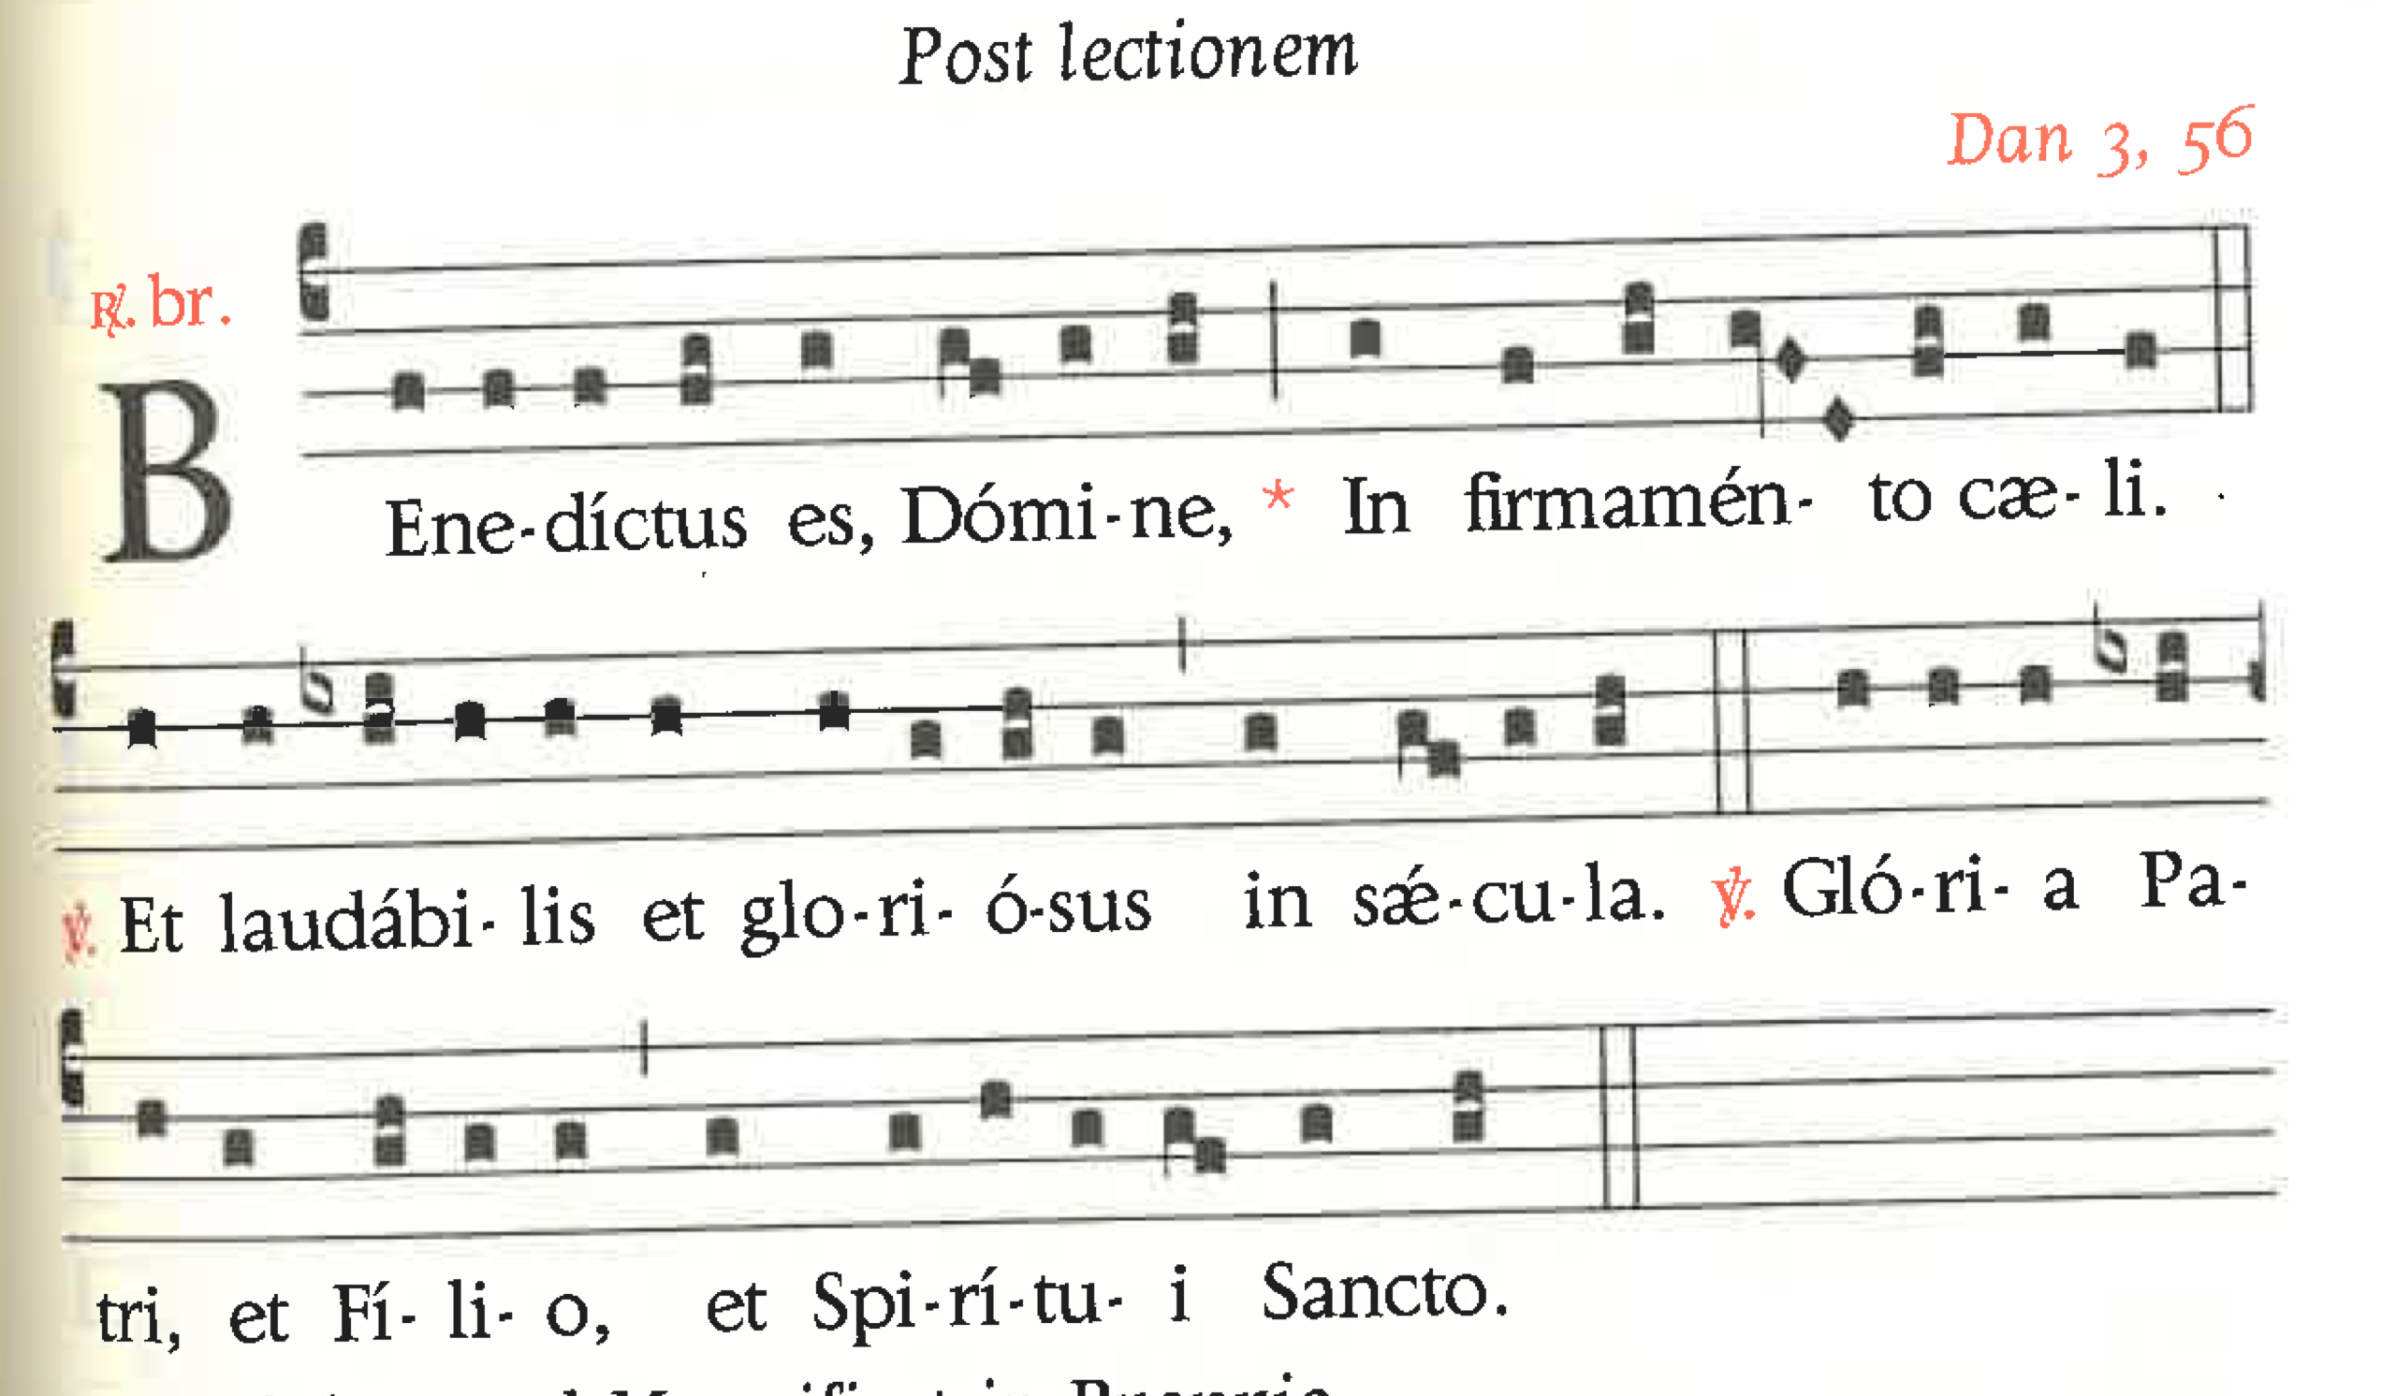

**Magnificat**

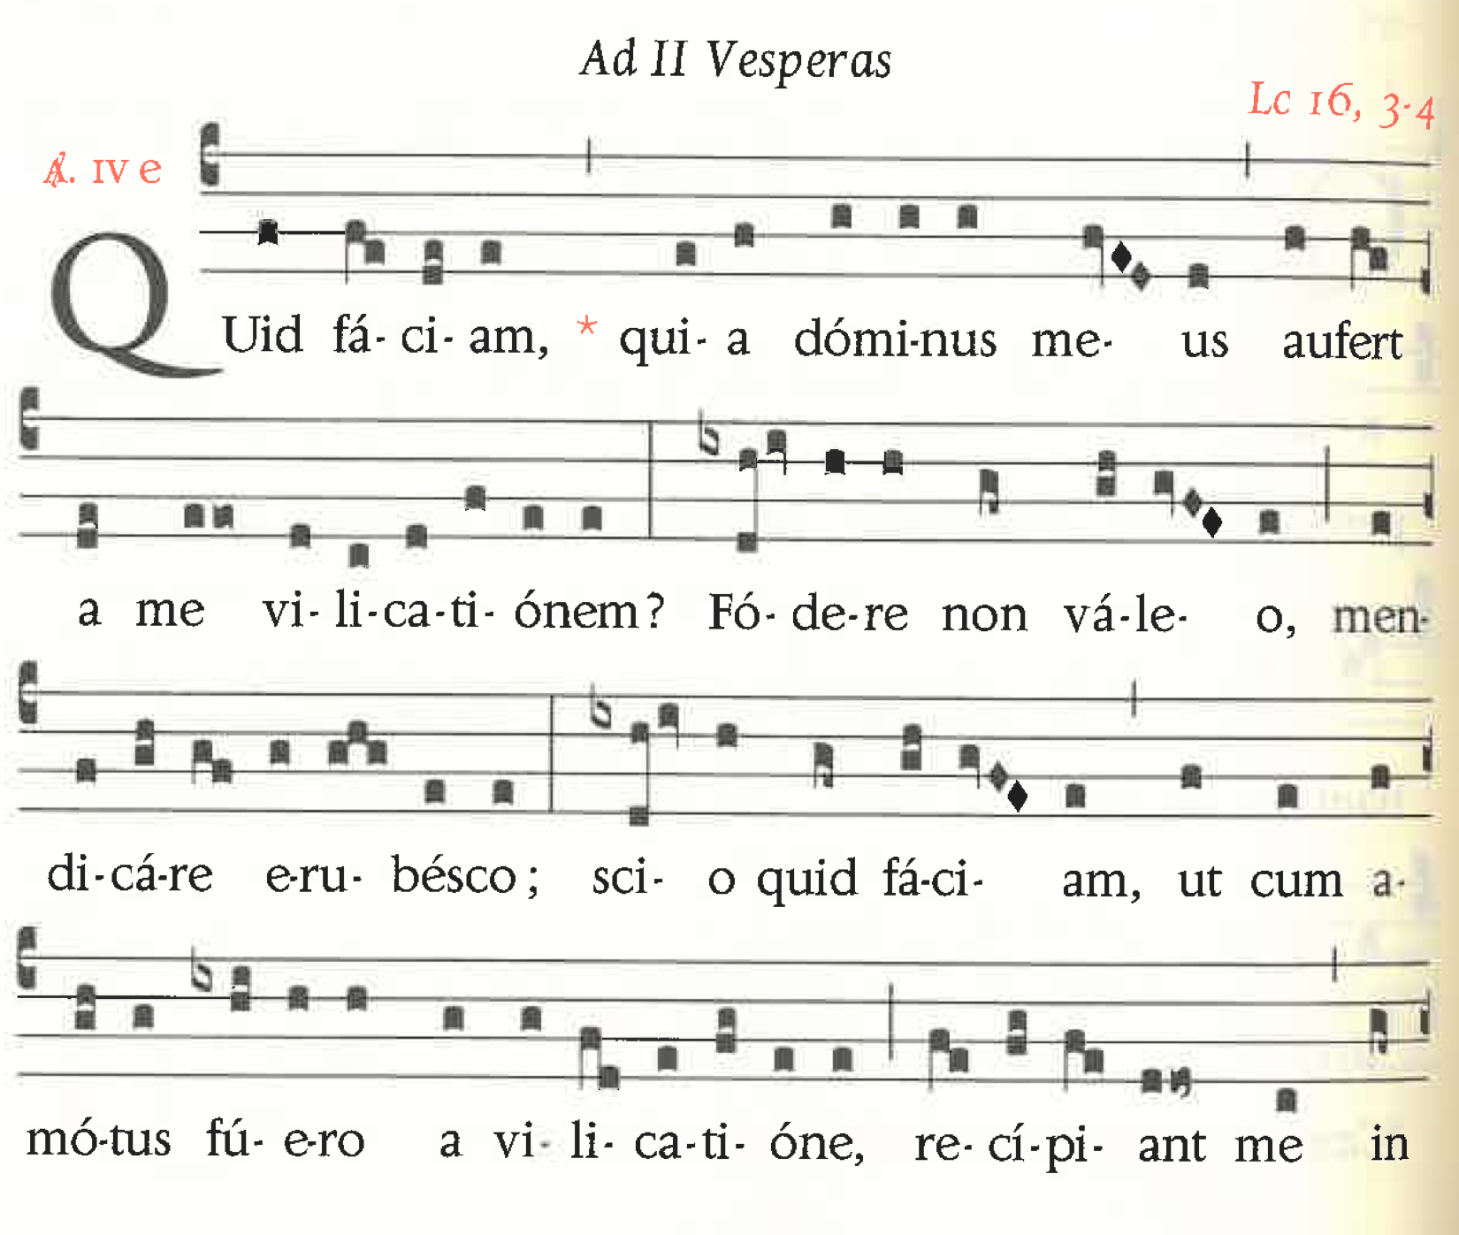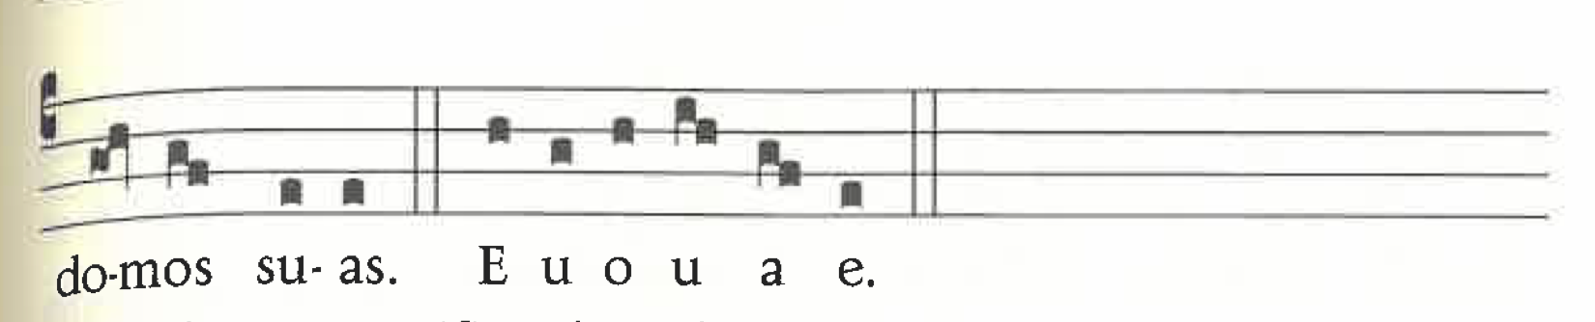







Intercessions

Our Father

Prayer

Blessing

Benedicamus Domino

